Bulk Completion of Sub-Tasks
Select the Sub-Tasks as normal in Issue Navigator. See Error: Reference source not found
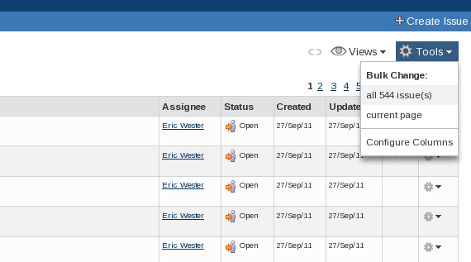
Issue Navigator
Select the Tools drop-down menu, situated on the right above the list of issues. From the Bulk Change section of the menu select either 'all 9999 issue(s)' or 'current page'

Step 1
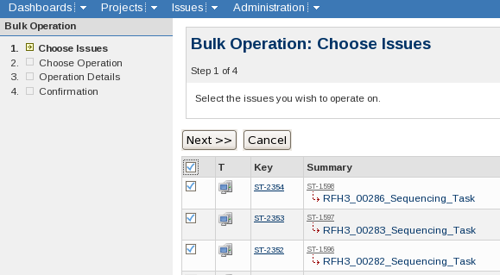
Bulk Operation: Step 1
Use the tick-box in the header section of the table to select all of the sub-tasks.
Click 'Next>>'

Step 2
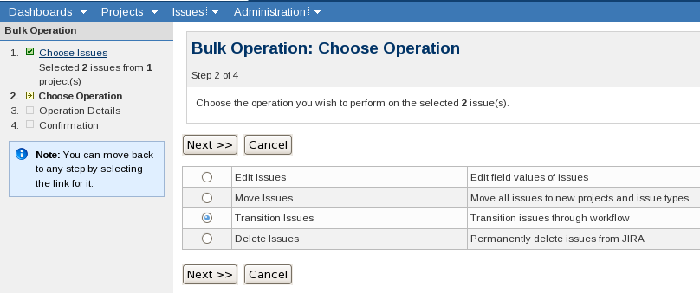
Bulk Operation: Step 2
Select 'Transition Issues'
Click 'Next >>'

Step 3a
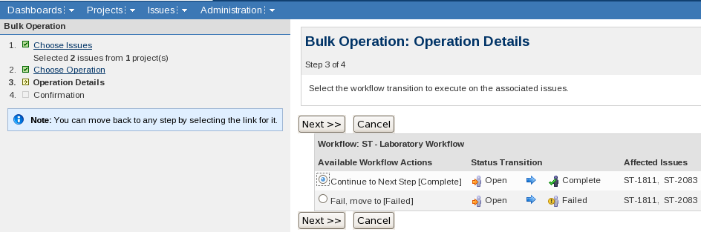
Bulk Operation: Step 3a
Select 'Continue to Next Step [Complete]'
Click 'Next>>'

Step 3b
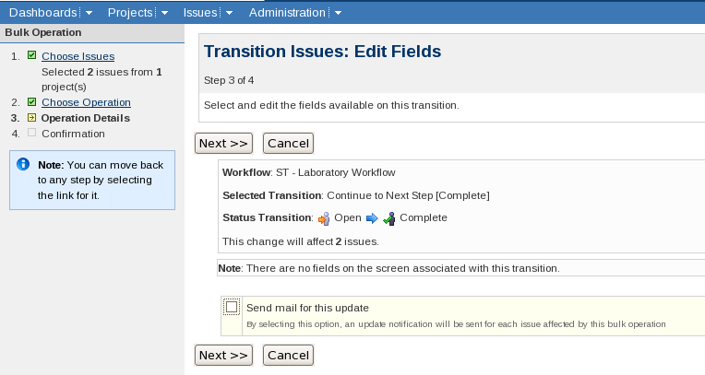
Bulk Operation: Step 3b
Deselect the check-box next to 'Send mail for this update' (if necessary)
Click 'Next >>'

Step 4
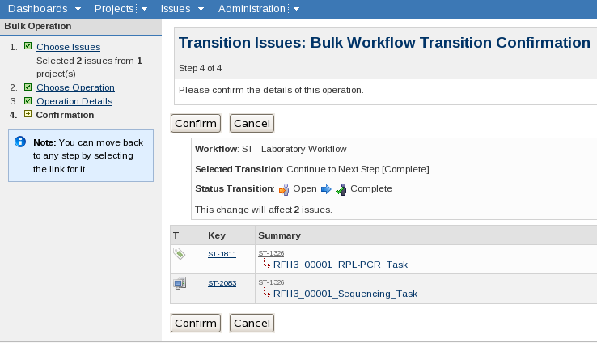
Bulk Operation: Step 4
Click 'Confirm'

Viewing only open sub-tasks
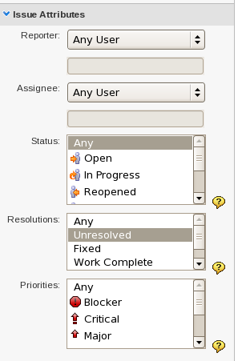
Issue Navigator: Search Side-bar
To hide the sub-tasks that have been completed make sure that the search has
'Resolutions:' set to 'Unresolved'.

Completing a Sub-task from the Parent Sample's Page
Near to the bottom of a Samples summary page is a block of Sub-Tasks (If the Sample has no Sub-Tasks then this block isn't shown).
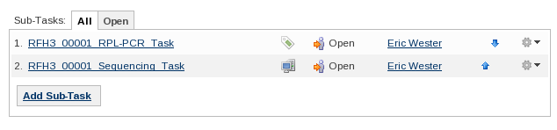
View Issue: Sub-tasks
Each Sub-Task is on a separate line. At the right hand side of the line is a cog symbol with an arrow pointing down:
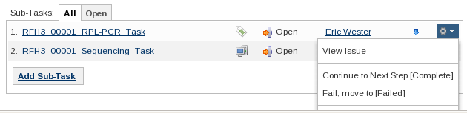
View Issue: Sub-tasks - Tools drop-down
Clicking on the symbol brings up a menu. The second section contains the 'transitions' available for the Sub-Task. Clicking 'Continue to Next Step [Complete]' will transition the task to Complete.

